The design of this website does not have the grand atmosphere on the market, but there is an old Chinese saying, "Although a sparrow is small, it has all the viscera". This means that even if something is small, it covers everything you need. Just like the website I designed this time, I want to make a fruit mall. Naturally, as a big country of agricultural trade, China does not lack fruits, but the export quantity of fruits has been increasing in recent years, so I want to make a website of fruit mall, and introduce some fruit prices and their impressions to you. I specifically collected the price of fruit per kilogram in Finnish supermarkets on the Internet, and made the design of the corresponding amount of money. The specific operation and procedure operation are described in the report, and I will not repeat them here. The following images are some of my initial design ideas.

**Make the initial idea for the interface design of the web page:**

The navigation bar and shortcut keys of the home page are shown in Figure 1.

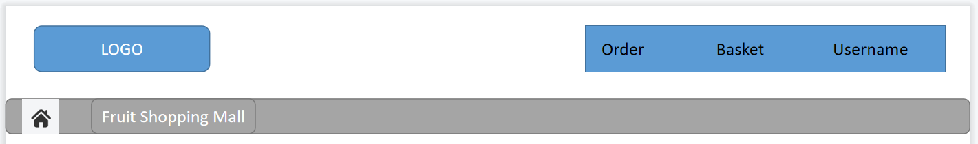

*Figure1 navigation bar*

The homepage interface design is shown in Figure2.

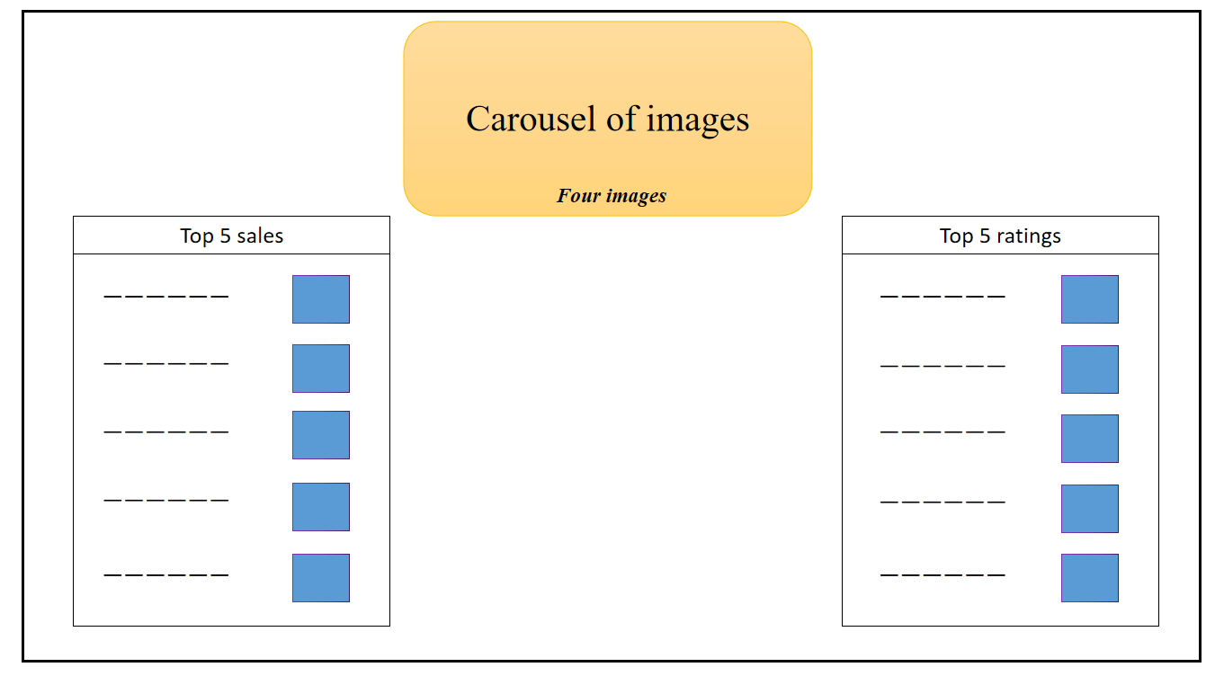

*Figure2 Home Page*

The commodity display interface is shown in Figure 3.

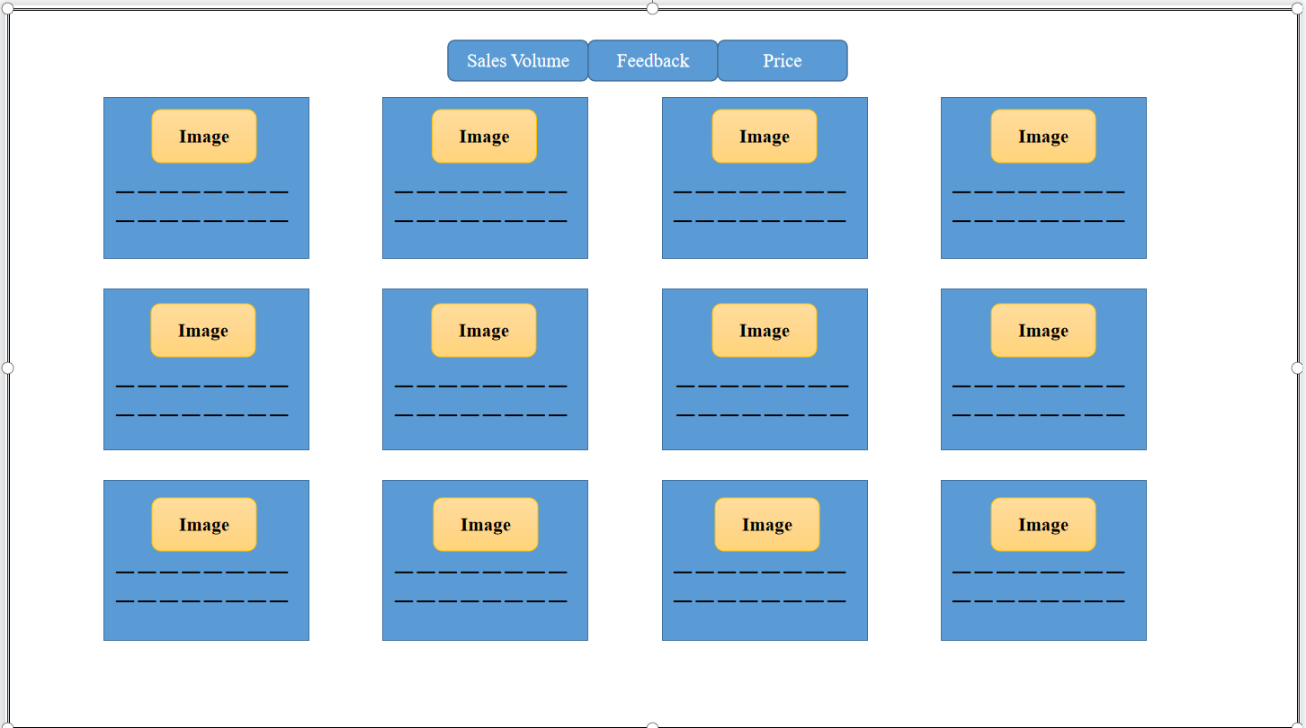*Figure 3 display interface*

The order design interface is shown in Figure 4.

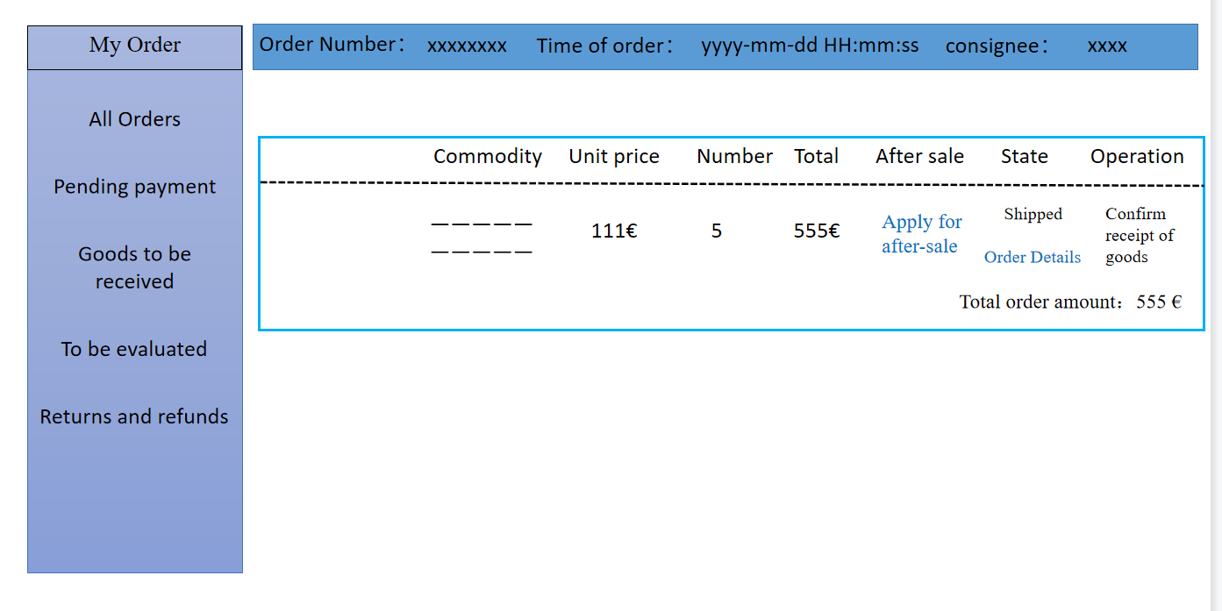

*Figure 4 order*

The basket design interface is shown in Figure 5.

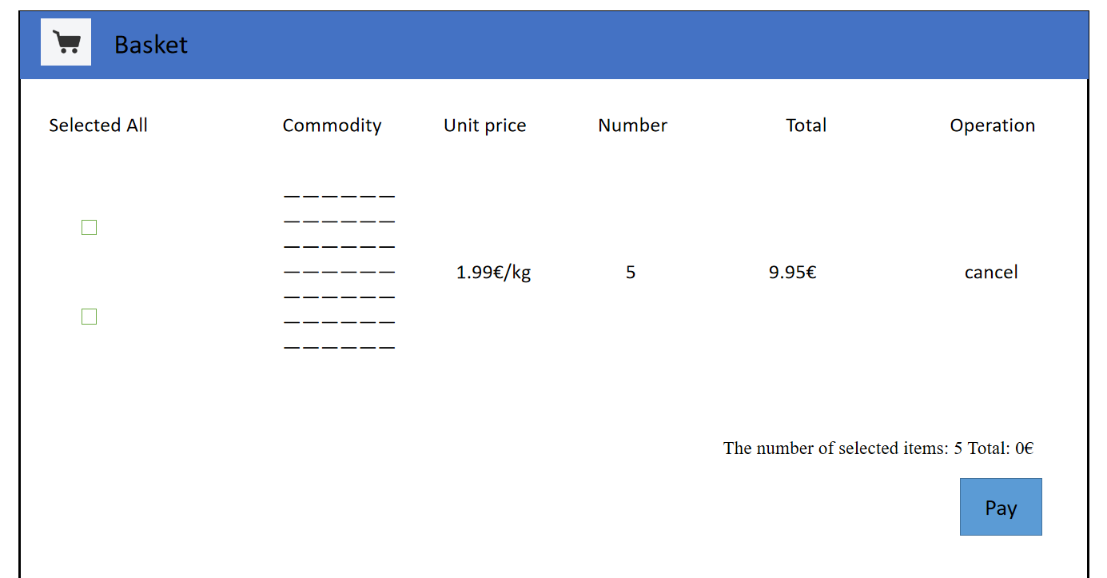

*Figure 5 basket*